**Homework #6- Chat Room Protocol**

Notes from Tuesday:

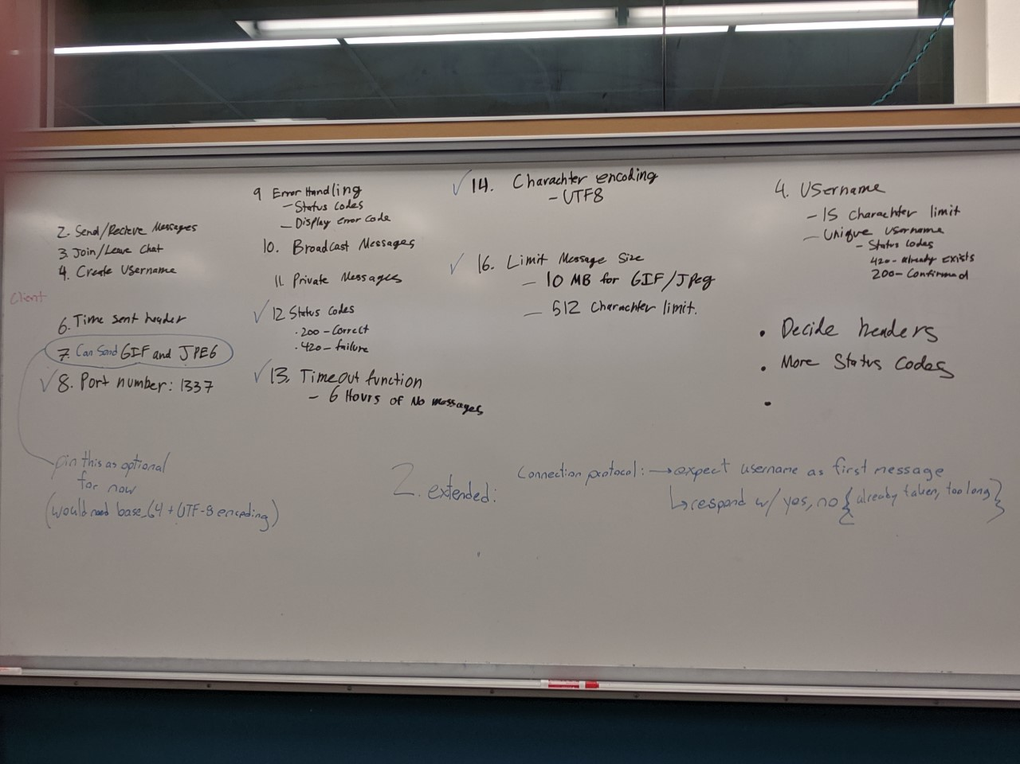

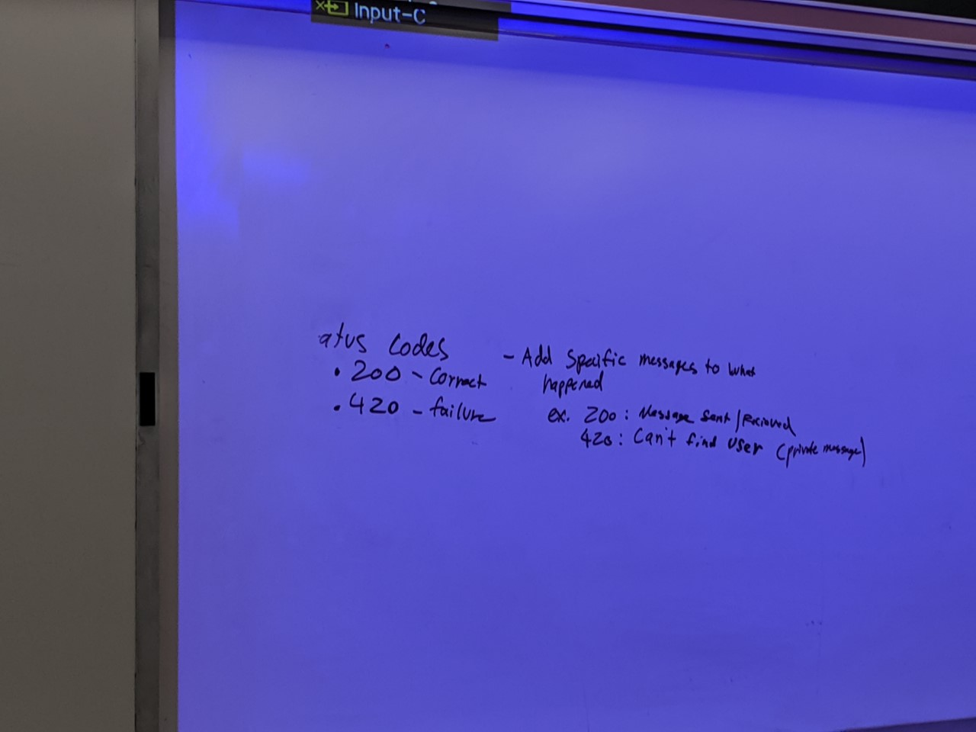

Notes from Thursday:

Message Formatting:

* UT-8 encoding
* Port 1337
* Message limit 512 characters
* Username limit 15 characters

**Commands:**

* JOIN : Join is sent to all other users as a global broadcast, but only after the server has verified that the requested username is valid. **Including the sender**
* LEAV: LEAV is sent to all other users as a global broadcast with an empty message content
* PVMG: PVMG is sent to just the specified user **including the sender**
* BDMG: broadcast a message to all users **including the sender**
* STAT: Specifies the server sending a status code back to a client, concerning a message that the client had sent
  + CASE SENSITIVE ALL UPPERCASE COMMANDS

**Message Content Details:**

Command: Just the command + | +

Source: The source username + | +

Destination: a single username on the server, or “all” + | +

Time Sent: yyyy-mm-dd-hh-mm-ss UTC + \r\n +

Content: “message” = your username on a join (15 character)

= “” on leave

= “512 character: on pvmg or bdmg

* \r\n

**Message formating:**

BDMG|cool username|destination user|2019-11-17-08-32-13%\r\n

Hello this is my message\r\n

ON A JOIN (CLIENT TO SERVER) → username and message fields should both be the desired username that you want to join the chatroom with.

**Status code formatting:**

STAT|200

STAT|421

Username allowed characters: a-z, A-Z, 0-9, space, _, -, $, ^, ~, ;

-- new lines cannot be a part of the message

Errors:

200 ok

400 not ok

420 bad username (for joins) (too many characters/taken already/vertical bar in username)

421 invalid username (for private message)

**USE CASES**

Joining

Client to server (user katherine joins the chat)

JOIN|katherine|all|current UTC time\r\n

katherine\r\n

Server to katherine (on successful join)

STAT|200

Server to all clients

JOIN|katherine|all|current UTC time\r\n

katherine has joined the chat\r\n

Public Message

Client to server(user katherine to all clients)

BDMG|katherine|all|current UTC time\r\n

This is a message\r\n

Server to katherine(on successful public message)

STAT|200

Server to all clients

BDMG|katherine|all|current UTC time\r\n

katherine: This is a message\r\n

Private message

Client to server (user katherine to user sanskriti)

PVMG|katherine|sanskriti|current UTC time\r\n

This is a message to sanskriti\r\n

Server to katherine (on successful private message)

STAT|200

Server to katherine(on unsuccessful private message due to invalid username)

STAT|421

Server to sanskriti

PVMG|katherine|sanskriti|current UTC time\r\n

katherine: This is a message to sanskriti\r\n

Exiting

Client to server(user katherine leaving the chat)

LEAV|katherine|all|current UTC time\r\n

Server to katherine (on successful leave)

STAT|200

Server to all clients

LEAV|katherine|all|current UTC time\r\n

katherine: katherine has left the chat\r\n